Implementation of a Neural Network for Movement with the Alternating Tripod Gate for Lynxmotion Hexapod Robot

Jack Jiang Computer and Information Science Department
Under Graduate Lab Researcher
Brooklyn College

Abstract— In order to achieve an alternating tripod gate that is biometic to control of walking in actual crabs, we will be developing a neural network controller for the Lynxmotion Hexapod robot. This network will take in inputs from range [0,1] and translating them to servo pulse width modulation positions ranging from [500, 2500]. We will coordinate the servos to move together to create alternating tripod gate stance. Once in the alternating tripod gate stance, we will be using a Wilson Oscillator to generate the oscillating movement for the alternating tripod gate. With the Wilson Oscillator, we can have the hexapod take steps.

- Introduction
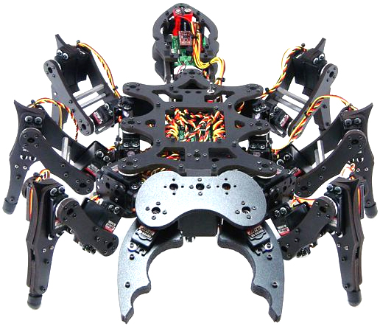
Hexapod robots are able to traverse terrain efficiently and stably. With six legs, hexapod robots are able move through terrain using the alternating tripod gate. The alternating tripod gate is a stance in which the first and last leg of one side and the middle leg of the other side move in unison. This stance provides stability while the next step is taken. An implementation of an artificial neural network will be able to accept large amounts of input and process this information without consuming a lot of resources.
Figure 1. Lynxmontion Hexapod
In order to produce oscillating movements between the left and right side of the hexapod, a Wilson Oscillator can be used. The Wilson Oscillator model describes the dynamic interactions between excitatory and inhibitory model neurons. Excitatory and inhibitory neurons will affect each creating a push and pull relationship.

- Goals

To create the interface between the neural network and hexapod, we will need to convert the outputs from the neural network to pulse width modulation for servo control. The range of the pulse width modulation range from [500, 2500] whereas the network outputs range from [0,1]. We can use the equation 1500 + 2000D where D is the output from the network to model relationship between network output and pulse width modulation.
In order for the Lynxmotion hexapod to take steps with the alternating tripod gate, the legs must be in sync. The left and right side of the alternating tripod gate must be synchronized to move together while the other side balancing the hexapod. For all the legs to be synchronized, the servos on each leg of the hexapod must also be in sync. Each servo controls the angle of the leg at a different spot. Thes angle determined by the servos must be correct for the balance of the hexapod. The left and right side should be in antiphase to create steps, which is modelled through the Wilsons Oscillator.

- Approach

In order to create model the neural network we will be using, we will be using a five by five matrix to represent the network. We can model the network diagram with matrices. Our matrix for this network diagram will be five by five dimension.
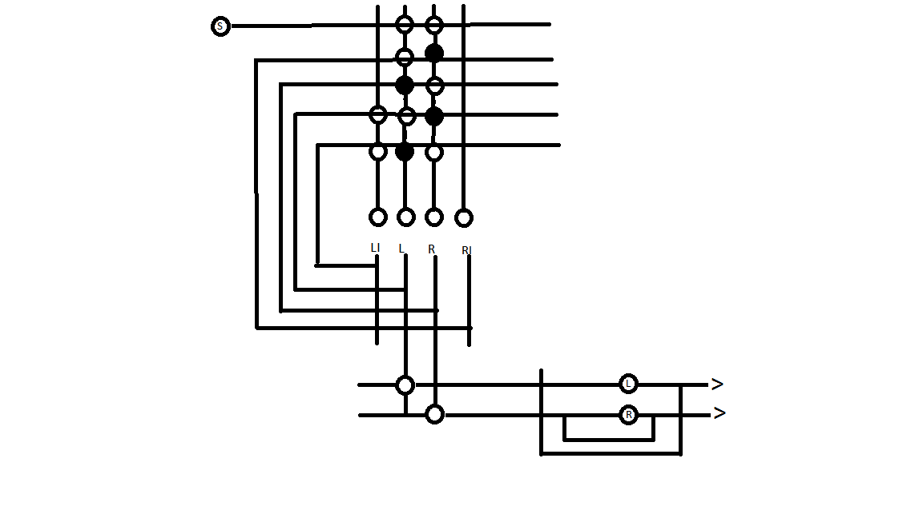
For the Wilson Oscillator to work, we need to implement a bias to the left or the right to kick start the system. The bias allows the oscillations to begin on one side, otherwise the left and right will move in unison rather than oscillations.
Weighs in the neural network determine the strength of the connections. In order for the Wilson Oscillator to create smooth and rhythmic oscillations, we need to find the small window of weights that work. We would need to run the network with different weights and to determine what are the optimal weight values.

- Validation

We test the outputs from the neural network with a loop through one thousand time steps. From the outputs, we can see if there is an oscillation of values from the left and right side. Ideally, these numbers should be in perfect antiphase of each other if our network’s Wilson Oscillator is perfectly calibrated.
From testing our outputs, oscillations began after about four hundred time steps and runs until about nine hundred time steps before it dies out. Our output shows the left and right are running in antiphase of each other.

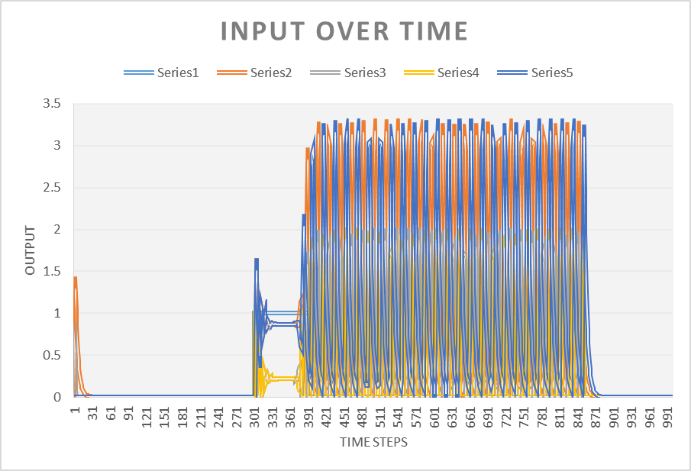

- Summary

We have created an artificial neural network that can use the Wilson Oscillator model to create oscillations for our Lynxmotion Hexapod robot. These oscillations are how the left and right side of the alternating tripod gate will be taking steps.
From our data, our Wilson Oscillator is not running perfectly. Oscillations should start almost immediately instead of beginning at around time step four hundred. These oscillations should be in perfect antiphase of each other to provide smooth steps for the hexapod.
The weights for our network needs to be tweaked for a smoother Wilson Oscillator. A training algorithm can be implemented to train our network to find the most optimized weights. We can do this by using a cost function to represent the performance of our network. Then by using an error function, we can see how optimized our weights are.
Once we have achieved the optimal weights for our network, use the network inside the hexapod. We would need to control the servos of the robot simultaneously. Coordinating the servo angles and which legs to move simultaneously to a precise rhythm will also be necessary for the robots to take its first steps. The oscillation speed between the left and right side of the alternating tripod gate will determine the speed in which the robot will travel.

Acknowledgement
I would like to thank all the researchers and staff of the BCR lab for help and constructive criticism. I would like to especially thank Professor Frank W. Grasso for his advice and tutelage.

References
[1] T. J. Anastasio, Tutorial on neural systems modeling. Sunderland, MA, United States: Sinauer Associates Inc.,U.S., 2009.
[2] D. Wilson, "The Central Nervous Control of Flights in a Locus," Journal of Experimental Biology, no. 38, pp. 471–490, 1961.

Appendix

//network input matrix

numberOfInputs 1

numberOfOutputs 2
numberOfInterNeurons 2
networkDimension 5
networkActivations
0.000000 0.000000 1.00000 0.000000 0.000000
networkOutputs
0.000000 0.000000 0.000000 0.000000 0.000000
neuronThreshold
0.000000 0.000000 0.000000 0.000000 0.000000
neuronLearningRate
0.000000 0.000000 0.000000 0.000000 0.000000
neuronRefactoryState
0.000000 0.000000 0.000000 0.000000 0.000000
neuronWeightTotal
1.000000 1.000000 1.000000 1.000000 1.000000
networkweights
0 0 1.0 1.0 0
0 .8 -0.9 0 0
0 .8 0.9 -0.9 0
0 0 -0.9 0.9 .8
0 0 0 -0.9 .8

networkinputs
0
networkoutputs
0.000000 0.000000
networkplasticweightsmask
0 0 0 0 0
0 0 0 0 0
0 0 0 0 0
0 0 0 0 0
0 0 0 0 0

//network code

// SIngleMatrixNetwork.cpp : Defines the entry point for the console application.
//

#include "stdafx.h"
#include "Network.h"
#include <math.h>
#include <stdio.h>

int main(int argc, char* argv[])
{
Network jack("jacktestc.txt");

int i = 0;
double input[6];
while (i < 1000) { //1000 time step loop

input[0] = 0.0;
if (i > 300 && i < 700) input[0] = 1.0;
if (i > 600 && i < 800) input[0] = 1.0;
if (i > 650 && i < 850) input[0] = 1.0;
jack.setNetworkInput(input);

jack.cycleNetwork();
jack.printNetworkOutputState();

jack.writeNetworkOutputStateToFile("oscillator23.txt");
++i;
}

return 0;

}

